Tela de Exibição de Todos os Clientes (9180)

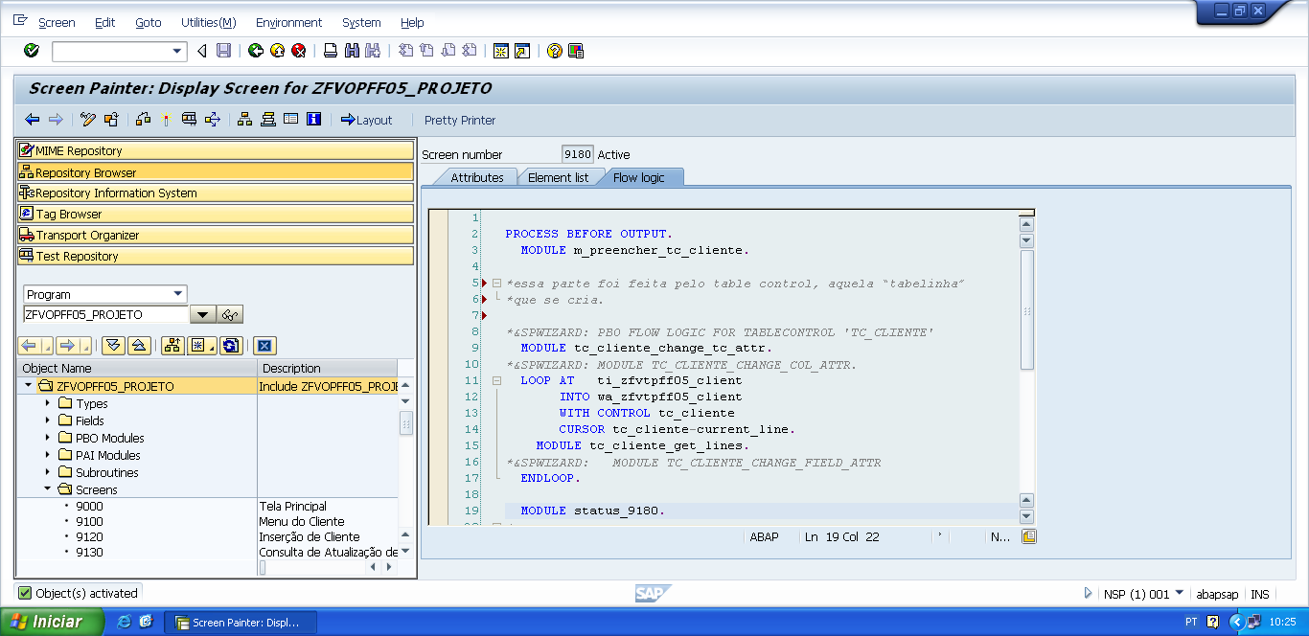

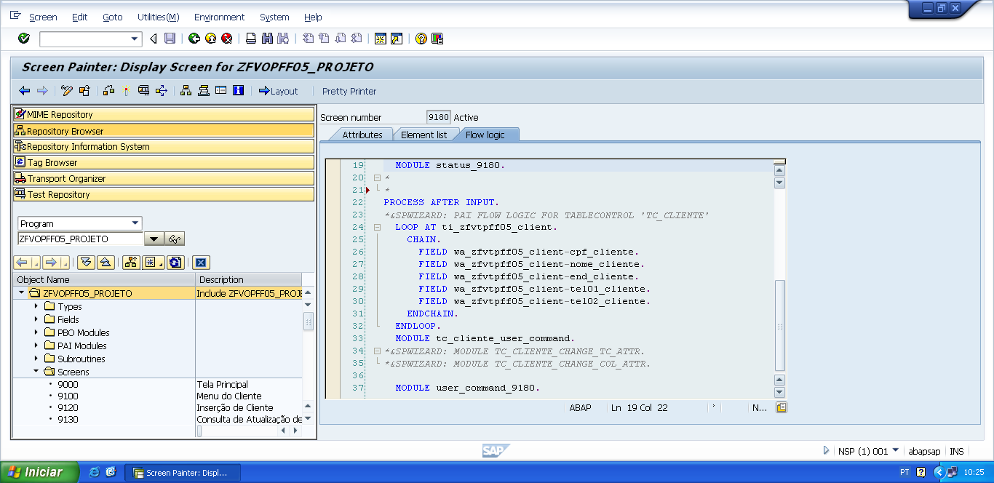

PROCESS BEFORE OUTPUT.  
  MODULE m_preencher_tc_cliente.  
  
*essa parte foi feita pelo table control, aquela “tabelinha”   
*que se cria.  
  
*&SPWIZARD: PBO FLOW LOGIC FOR TABLECONTROL 'TC_CLIENTE'  
  MODULE tc_cliente_change_tc_attr.  
*&SPWIZARD: MODULE TC_CLIENTE_CHANGE_COL_ATTR.  
  LOOP AT   ti_zfvtpff05_client  
       INTO wa_zfvtpff05_client  
       WITH CONTROL tc_cliente  
       CURSOR tc_cliente-current_line.  
    MODULE tc_cliente_get_lines.  
*&SPWIZARD:   MODULE TC_CLIENTE_CHANGE_FIELD_ATTR  
  ENDLOOP.  
  
  MODULE status_9180.

*&---------------------------------------------------------------------*  
*&      Module  M_PREENCHER_TC_CLIENTE  OUTPUT  
*&---------------------------------------------------------------------*  
*       text  
*----------------------------------------------------------------------*  
MODULE m_preencher_tc_cliente OUTPUT.  
  
  PERFORM f_preencher_tc_cliente.  
  
ENDMODULE.                 " M_PREENCHER_TC_CLIENTE  OUTPUT

*&---------------------------------------------------------------------*  
*&      Form  F_PREENCHER_TC_CLIENTE  
*&---------------------------------------------------------------------*  
*Esse FORM preenche os dados que estão na tabela transparente de  
* cliente(zfvtpff05_client) para a tabela interna do programa referente  
*á cliente (ti_zfvtpff05_client).  
*----------------------------------------------------------------------*  
*  -->  p1        text  
*  <--  p2        text  
*----------------------------------------------------------------------*  
FORM f_preencher_tc_cliente .  
  
  SELECT cpf_cliente  
         nome_cliente  
         end_cliente  
         tel01_cliente  
         tel02_cliente  
  FROM zfvtpff05_client  
  INTO TABLE ti_zfvtpff05_client.  
  
  IF sy-subrc IS INITIAL.  
  
    SORT ti_zfvtpff05_client BY cpf_cliente.  
  
  ELSE.  
  
    MESSAGE e000(zfvclpff05).  
  
  ENDIF.  
  
ENDFORM.                    " F_PREENCHER_TC_CLIENTE

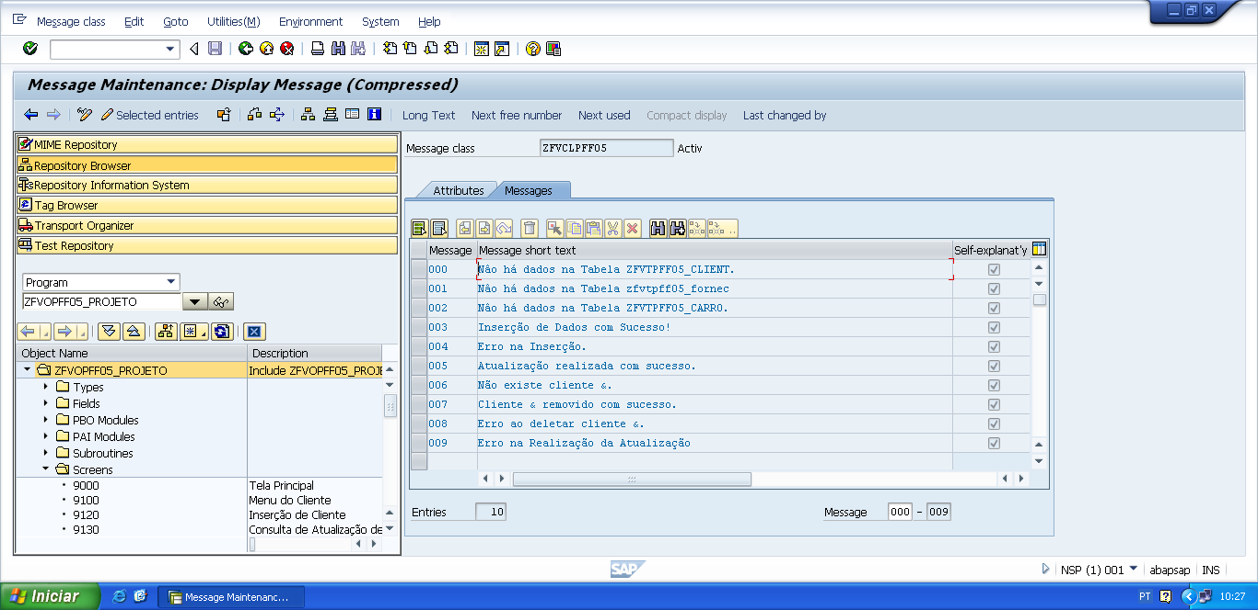

*&---------------------------------------------------------------------*  
*&      Module  STATUS_9180  OUTPUT  
*&---------------------------------------------------------------------*  
*       text  
*----------------------------------------------------------------------*  
MODULE status_9180 OUTPUT.  
  SET PF-STATUS 'STATUS9180'.  
  SET TITLEBAR 'TITULO9180'.  
  
ENDMODULE.                 " STATUS_9180  OUTPUT

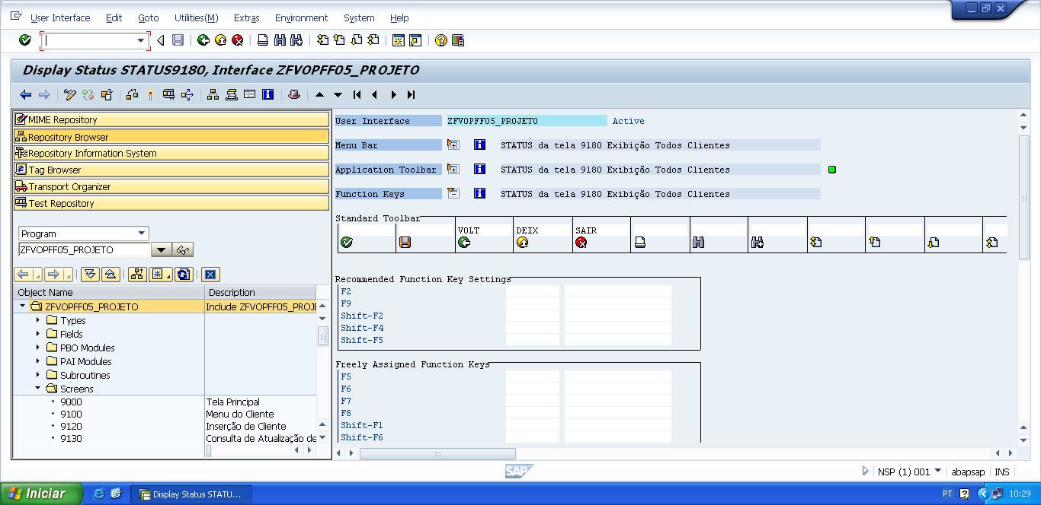

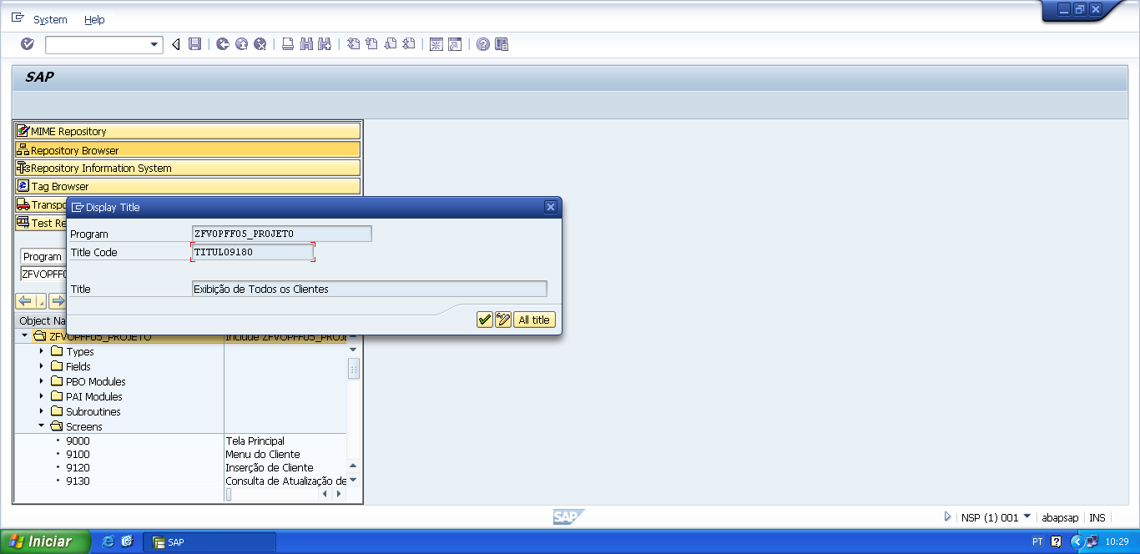

PROCESS AFTER INPUT.

*&SPWIZARD: PAI FLOW LOGIC FOR TABLECONTROL 'TC_CLIENTE'  
  LOOP AT ti_zfvtpff05_client.  
    CHAIN.  
      FIELD wa_zfvtpff05_client-cpf_cliente.  
      FIELD wa_zfvtpff05_client-nome_cliente.  
      FIELD wa_zfvtpff05_client-end_cliente.  
      FIELD wa_zfvtpff05_client-tel01_cliente.  
      FIELD wa_zfvtpff05_client-tel02_cliente.  
    ENDCHAIN.  
  ENDLOOP.  
  MODULE tc_cliente_user_command.  
*&SPWIZARD: MODULE TC_CLIENTE_CHANGE_TC_ATTR.  
*&SPWIZARD: MODULE TC_CLIENTE_CHANGE_COL_ATTR.  
  
  MODULE user_command_9180.

*&---------------------------------------------------------------------*  
*&      Module  USER_COMMAND_9180  INPUT  
*&---------------------------------------------------------------------*  
*       text  
*----------------------------------------------------------------------*  
MODULE user_command_9180 INPUT.  
  
  v_okcode = sy-ucomm.  
  
  CASE v_okcode.  
    WHEN 'VOLT'.  
      PERFORM f_voltar.  
    WHEN 'DEIX'.  
      PERFORM f_deixar.  
    WHEN 'SAIR'.  
      PERFORM f_sair.  
  ENDCASE.  
  
  CLEAR v_okcode.  
ENDMODULE.                 " USER_COMMAND_9180  INPUT

*&---------------------------------------------------------------------*  
*&      Form  F_VOLTAR  
*&---------------------------------------------------------------------*  
* FORM de voltar, serve para voltar automaticamente para a tela  
*anterior da tela atual.  
*----------------------------------------------------------------------*  
*  -->  p1        text  
*  <--  p2        text  
*----------------------------------------------------------------------*  
FORM f_voltar.  
  
*Volte para á tela 9000 (Tela Principal)  
*ou  
**CALL SCREEN '9000'.**  
  PERFORM f_limpar_variaveis.  
  SET SCREEN 0.  
  LEAVE SCREEN.  
  
  
ENDFORM.                    " F_VOLTAR  
  
*&---------------------------------------------------------------------*  
*&      Form  F_DEIXAR  
*&---------------------------------------------------------------------*  
*       text  
*----------------------------------------------------------------------*  
*  -->  p1        text  
*  <--  p2        text  
*----------------------------------------------------------------------*  
FORM f_deixar .  
  
  LEAVE LIST-PROCESSING.  
  
ENDFORM.                    " F_DEIXAR  
  
*&---------------------------------------------------------------------*  
*&      Form  F_SAIR  
*&---------------------------------------------------------------------*  
*       text  
*----------------------------------------------------------------------*  
*  -->  p1        text  
*  <--  p2        text  
*----------------------------------------------------------------------*  
FORM f_sair.  
  
  LEAVE LIST-PROCESSING.  
  
ENDFORM.                    " F_SAIR